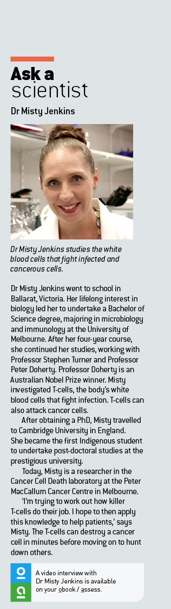Ask a scientist worksheet

6.6 Eukaryotic cells undergo mitosis

Pages 108–109

Dr Misty Jenkins – immunologist

1 From the video introduction, what do you think an immunologist studies?

________________________________________________________

_____________________________________________________________

_____________________________________________________________

2 How many researchers work at the Peter MacCallum Cancer Centre?

_____________________________________________________________

3 Your immune system is also known as your body’s defence system. Brainstorm the ways that your body protects you against disease.

________________________________________________________

_____________________________________________________________

_____________________________________________________________

4 What are T-cells?

________________________________________________________

_____________________________________________________________

5 Assign jobs the following cells as if they were people in the military.

|  |  |
| --- | --- |
| Cell | Job |
| Helper T-cells |  |
| B-Cells |  |
| Killer T-cells |  |

6 Create a See-Know-Wonder table for the following image.

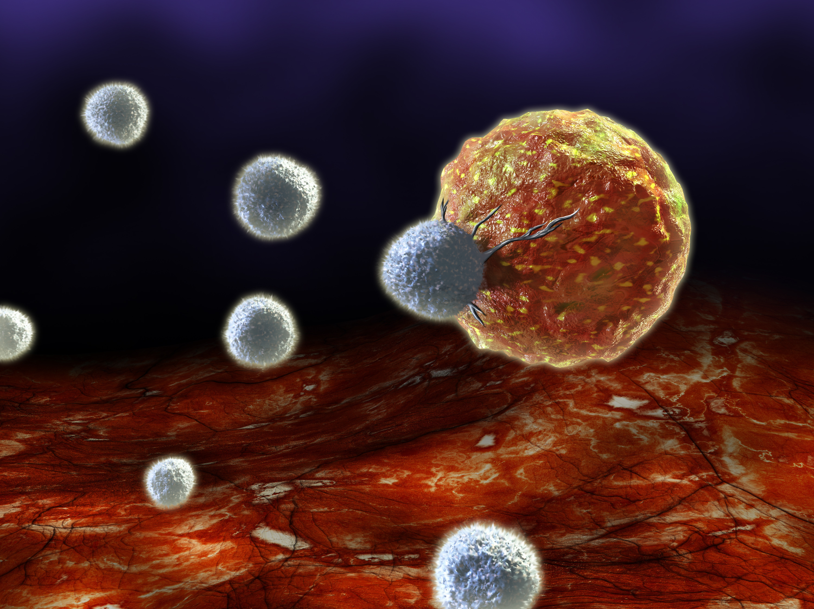

|  |  |  |
| --- | --- | --- |
| See | Know | Wonder |
| (What can you see in the image?) | (What do you know about the image?) | (What do you wonder about the image?) |
|  |  |  |